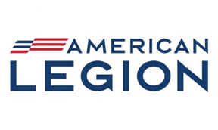
American Legion Post 45 – Canton, GA
Agenda - General Membership Meeting
26 March 2026

Meeting Call to Order

Sergeant of Arms

Prayer, Pledge of Allegiance and the Preamble

Roll Call of Officers and Quorum

Review and motion for approval of minutes

Welcome/Introductions of Guest

Commander’s Report

Adjutant’s Report

Finance Report

Committee Reports:

- SR Vice Commander (Joey Price)
- Membership (Lynne Rollins)
- Chaplain (Fred McDougal)
- School Awards (Lynne Rollins)
- Service Officer/Homeless Veterans (Jim Lindenmyer)
- Community Outreach (Dan Frajt)
- Americanism School Essay Committee (Lee Guard)
- Building and Grounds (Dub West)
- Blood Donor (Carlton Yancey)
Sons of the American Legion Report (Joe Farrell):
Auxiliary Report (Betty Lewis):
Old Business
New Business/Motions

Announcements/Good of the Legion

Closing Prayer

Sergeant of Arms

Adjournment

Prepared By:
//signed/mw/23March2026
MARGET WEATHERBY
Jr. Vice Commander
Post 45 – Canton, GA

